Brief Report
7th KIPRRA Kenya Think Tanks Symposium
Date: 22 April 2026
Venue: Weston Hotel, Nairobi
The 7th KIPRRA Kenya Think Tanks Symposium convened senior representatives from government institutions, academia, and research organizations to strengthen collaboration in evidence-based policymaking and data systems integration. Key participants included KRA, KEMRI, Parliamentary research units (National Assembly and Senate), JKUAT, University of Nairobi (IDS), KALRO, Ministry of Health, Competition Authority, YEDF, AERC, iHub, and GPIN, among others. KIPRE was represented by Mr. Patrick Mwaura of Data science and analytics on behalf of Director Capacity Building, Partnership and Grant Management. (Dr. Danson Mwangi)
The symposium was led by the Acting Director, Economic Management (KIPPRA), Dr. Eliud Moyi, and moderated by the Principal Statistician, Mr. Samuel Kaunde.
Key issues emerging
- Strong institutional commitment to improving data generation, management, analysis, and dissemination to support timely, credible and evidence based policy decisions.
- Increasing emphasis on multidisciplinary collaboration and integrated data ecosystems to strengthen the national knowledge value chain.
- KRA highlighted availability of administrative data for research (subject to legal and ethical frameworks) and outlined tax provisions supporting research and agricultural inputs (Income Tax Act Sec. 15(2) (n); Finance Act Sec. 5(2–3)).
- Multiple institutions are establishing data centers, AI hubs, and centers of excellence to enhance data sharing and analytics capacity.
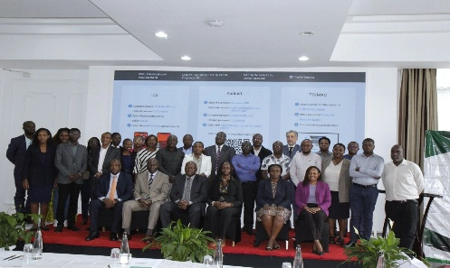
- KIPPRA reported ongoing World Bank support towards an AI-enabled Data Hub to strengthen modelling and policy research and analysis in line with the Medium Term Plan (MTP).
Strategic implication
The engagement underscored the need for coordinated investment in data infrastructure, interoperability, and timely analytics to address gaps in the policy advisory value chain and enhance delivery of evidence-based decisions.
https://www.linkedin.com/posts/kippra_today-kippra-convened-the-kenya-think-tanks-activity-7452824404683632641-JGlx?utm_source=social_share_send&utm_medium=member_desktop_web&rcm=ACoAABjXIGsB2ehbs6p_BJcdtqtW8jJhYy-vzs4

